5/6/2023

COAL LAB 11

20k1898

**Task 1:**

INCLUDE Irvine32.inc

.data

array1 DWORD 1, 2, 3, 4, 5, 6, 7, 8, 9, 10

array2 DWORD 10 DUP(?)

.code

main PROC

mov esi, OFFSET array1

mov ecx, LENGTHOF array1

; push elements from array1 onto the stack

push_loop:

push [esi]

add esi, TYPE array1

loop push_loop

; pop elements from the stack into array2

mov esi, OFFSET array2

mov ecx, LENGTHOF array2

pop_loop:

pop [esi]

add esi, TYPE array2

loop pop_loop

; display array2 to verify that elements were moved successfully

mov esi, OFFSET array2

mov ecx, LENGTHOF array2

print_loop:

mov eax, [esi]

call WriteDec

call crlf

add esi, TYPE array2

loop print_loop

exit

main ENDP

END main

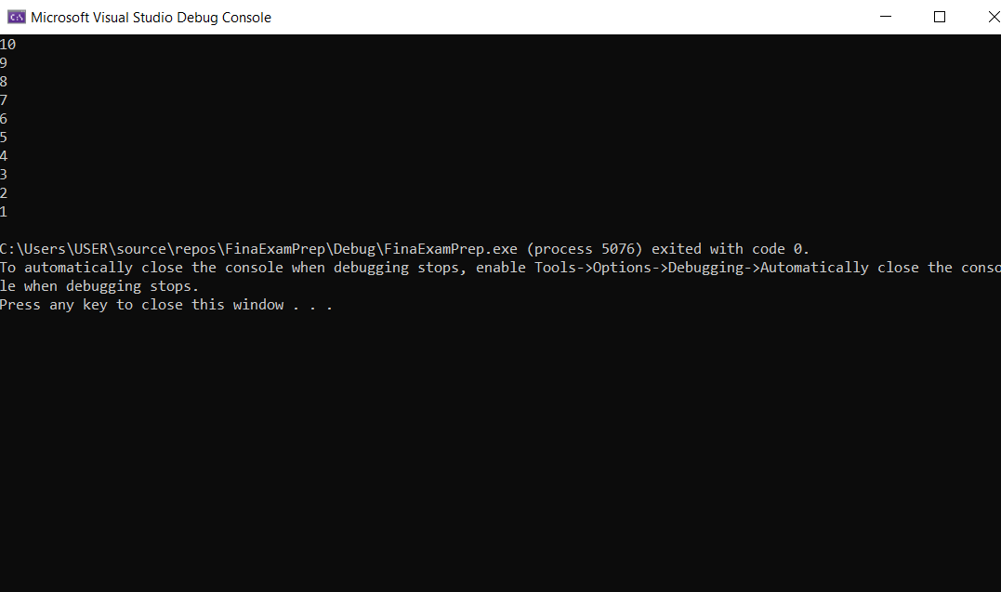

**Task 2:**

Include Irvine32.inc

.data

arr1 DWORD 1,2,3,4,5

arr2 DWORD 1,2,3,4,5

text BYTE "The sum of the two arrays is: ",0

SUM DWORD ?

.code

MAIN PROC

call DumDumSum

exit

MAIN ENDP

DumDumSum PROC

call DumSum1

call DumSum2

mov edx,OFFSET text

call WriteString

mov eax,SUM

call WriteDec

ret

DumDumSum ENDP

DumSum1 PROC

mov ecx,LENGTHOF arr1

mov esi,0

Sum1:

mov eax,arr1[esi* TYPE arr1]

add SUM,eax

inc esi

loop Sum1

ret

DumSum1 ENDP

DumSum2 PROC

mov ecx,LENGTHOF arr2

mov esi,0

Sum2:

mov eax,arr2[esi* TYPE arr1]

add SUM,eax

inc esi

loop Sum2

ret

DumSum2 ENDP

END MAIN



Task 3:

Include Irvine32.inc

.data

star BYTE "*",0

COLUMN DWORD ?

SPACES DWORD ?

SPACE BYTE " ",0

CURRENT DWORD 1

prompt BYTE "Enter the number of columns: ",0

.code

MAIN PROC

mov edx,OFFSET prompt

call WriteString

call ReadInt

mov COLUMN,eax

mov SPACES,eax

call DrawPattern

exit

MAIN ENDP

DrawPattern PROC

mov ecx,COLUMN

XD:

mov ebx,ecx

mov ecx,SPACES

printSpace:

mov edx,OFFSET SPACE

call WriteString

loop PrintSpace

mov ecx,CURRENT

dec SPACES

printStars:

mov edx,OFFSET star

call WriteString

loop printStars

inc CURRENT

mov ecx,ebx

call crlf

loop XD

ret

DrawPattern ENDP

END MAIN

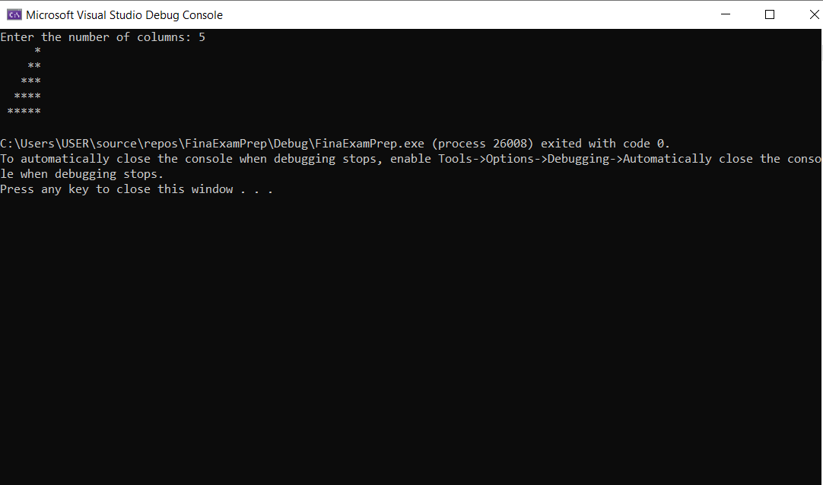

Task 4:

Include Irvine32.inc

.data

ALPHABETS BYTE "ABCDEFGHIJKLMNOPQRSTUVWXYZ",0

ROWS DWORD ?

SPACES DWORD ?

SPACE BYTE " ",0

CURRENT DWORD 1

prompt BYTE "Enter the number of rows: ",0

.code

MAIN PROC

mov edx,OFFSET prompt

call WriteString

call ReadInt

mov ROWS,eax

mov SPACES,eax

call DrawPattern

exit

MAIN ENDP

DrawPattern PROC

mov ecx,ROWS

mov esi,0

XD:

mov ebx,ecx

mov ecx,SPACES

printSpace:

mov edx,OFFSET SPACE

call WriteString

loop PrintSpace

mov ecx,CURRENT

DEC SPACES

printAlphabets:

mov al,ALPHABETS[esi* TYPE ALPHABETS]

call WriteChar

inc esi

CMP esi,26

jz resetESI

continueLoop:

loop printAlphabets

jmp proceed

resetESI:

mov esi,0

jmp continueLoop

proceed:

inc CURRENT

mov ecx,ebx

call crlf

loop XD

ret

DrawPattern ENDP

END MAIN

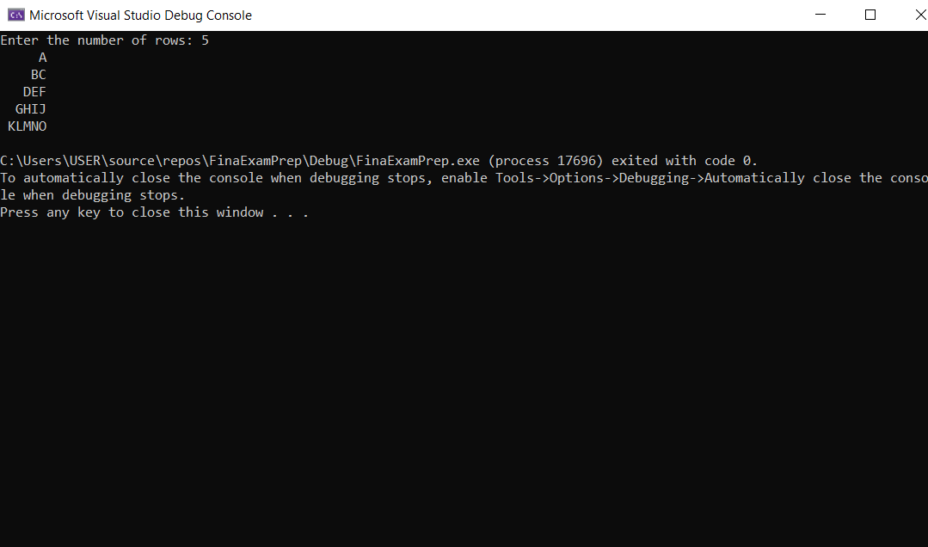

**Task 5:**

Include Irvine32.inc

.data

prompt BYTE "Enter the value of n: ",0

N DWORD ?

text BYTE "The Sum of the numbers is: ",0

SUM DWORD ?

.code

MAIN PROC

mov edx,OFFSET prompt

call WriteString

call ReadInt

mov N,eax

call sumTheNumbers

mov edx,OFFSET text

call WriteString

mov eax,SUM

call WriteDec

exit

MAIN ENDP

sumTheNumbers PROC

mov ecx,N

mov ebx,1

mov eax,0

mov SUM,eax

addNums:

add eax,ebx

inc ebx

loop addNums

mov SUM,eax

ret

sumTheNumbers ENDP

END MAIN

